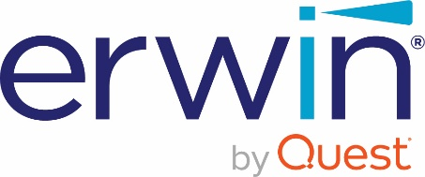 ACADEMIC PROGRAM ANNUAL RENEWAL
Thank you for participating in the erwin® Data Modeler (erwin DM) Academic Program. Please complete the information below and send to the following email address: erwin.education@quest.com with the subject line: Academic Program Renewal. Please do not open a ticket with support, the program Administrator will do that for you. We use this information to better understand how erwin DM is being used at your institution. There is also a section to provide feedback.
We hope the program is beneficial in the education of future data modelers and look forward to your feedback.
PLEASE NOTE: By completing this form and submitting as instructed above you confirm that the Institution’s use of the Licensed Program has been in compliance with the U.S. export laws, including the Export Administration Regulations and the Office of Foreign Asset Controls regulations. No exports or reexports of the Licensed Program have occurred without appropriate authorization of the U.S. Government. This assurance will be honored even after the expiration date of the licensing agreement.
Current License Code:
Institution Name:
Address:
Primary Contact Name:
Email:
Phone:

Please include the details of the courses that use erwin Data Modeler.
Course Name | Department | Professor Name | Start Date | End Date | Number of Students

Comments:

